C++ lab Questions

Question 1. Write a program to find the largest of three numbers.

#include <iostream>
using namespace std;
int main()
{
int a,b,c;
cout << "Enter first number : ";
cin >>a;
cout << "Enter second number : ";
cin >>b;
cout << "Enter third number : ";
cin >>c;
if(a>b && a>c)
cout <<"Largest = " << a;
else if(b>a && b>c)
cout <<"Largest = " << b;
else
cout <<"Largest = " << c;
return 0;
}
Output
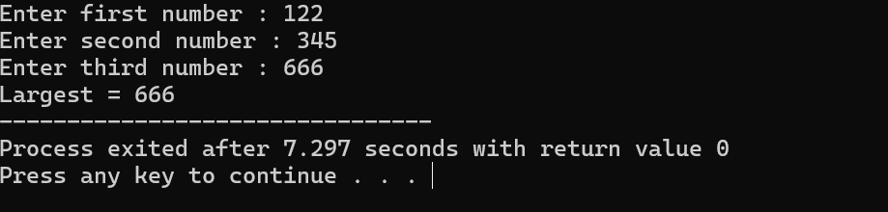

Question 2. Write a Program to Swap Two Numbers.
#include <iostream>
using namespace std;
int main()
{
int a,b,temp;
cout << "Enter first number : ";
cin >>a;
cout << "Enter second number : ";
cin >>b;
cout << "Number before swapping a= " << a <<"and b= " << b << endl;
temp = a;
a=b;
b=temp;
cout << "Number after swapping a= " << a <<"and b= " <<b;
return 0;
}
Output
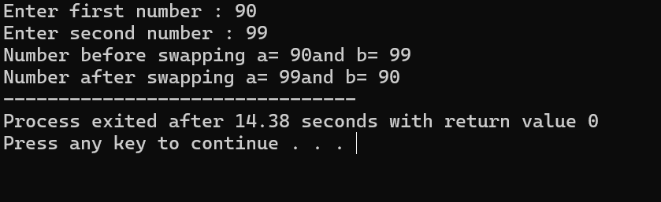
Question 3. Write a program to reverse a given number.
#include <iostream>
using namespace std;
int main()
{
int a,rem,rev=0;
cout << "Enter a number : ";
cin >>a;
while (a !=0)
{
rem = a % 10;
rev = rev*10+rem;
a=a/10;
}
cout << "Reversed number = " << rev;
return 0;
}
Output
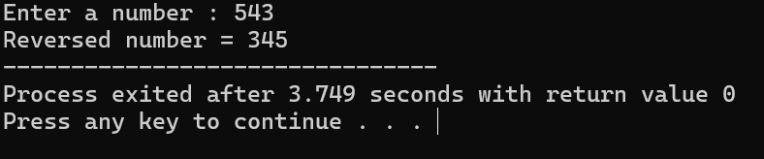
Question 4. Write a program to check whether a given number is prime.
#include <iostream>
using namespace std;
int main()
{
int a,i,count=0;
cout << "Enter the number ";
cin >> a;
for(i=1;i<=a;i++)
{
if (a%i ==0)
count ++;
}
if(count == 2)
cout << "prime number" ;
else
cout << "Not a prime number" ;
return 0;
}
Output
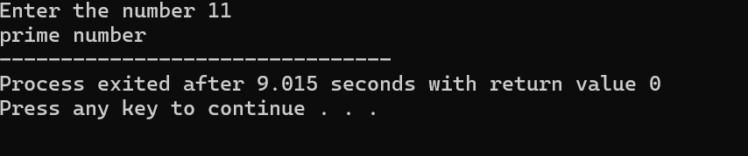
Question 5. Write a program to check whether a given year is leap year or not.
#include <iostream>
using namespace std;
int main()
{
int a;
cout << "Enter a year ";
cin >> a;
if(a%4 == 0 && a%100 != 0 && a%400 ==0 )
cout << "Leap year" ;
else
cout << "Not a leap year";
return 0;
}
Output
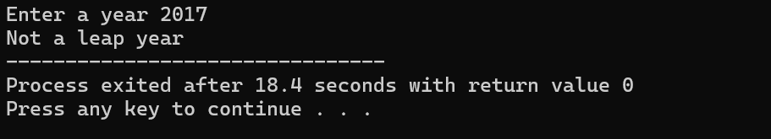

Question 6. Write a program to find the factorial of a given number.
#include <iostream>
using namespace std;

int main() {
int n;
long long fact = 1;
cout <<"Enter the number :";
cin >> n;

for(int i = 1; i <= n; i++) {
fact = fact * i;
}

cout << fact;
}

Output
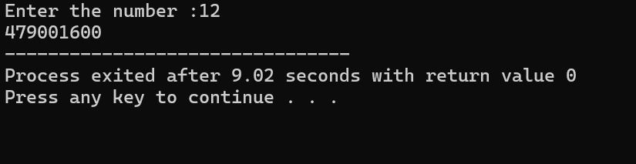

Question 7. Write a program to generate the Fibonacci series using while loop.
#include <iostream>
using namespace std;

int main() {
int n, a = 0, b = 1, c, i = 0;
cout <<"enter the number of series in febonnaci : ";
cin >> n;

while(i < n) {
cout << a << " ";
c = a + b;
a = b;
b = c;
i++;
}
return 0;
}
Output
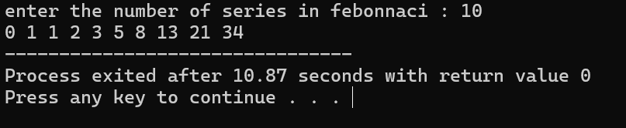
Question 8. Write a Program to Check Whether a Number Is a Palindrome or Not.
#include <iostream>
using namespace std;

int main() {
int n, temp, rev = 0;
cout << "Enter the number : ";
cin >> n;
temp = n;

while(n != 0) {
rev = rev * 10 + n % 10;
n /= 10;
}

if(temp == rev)
cout << "Palindrome";
else
cout << "Not Palindrome";
}
Output 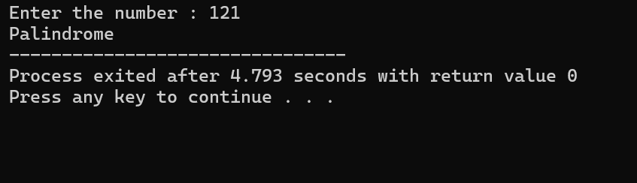
Question 9. Write a Program to Make a Simple Calculator.
#include <iostream>
using namespace std;

int main() {
int choice;
float num1, num2, result;
cout << "Simple Calculator\n";
cout << "1. Addition\n";
cout << "2. Subtraction\n";
cout << "3. Multiplication\n";
cout << "4. Division\n";
cout << "Enter your choice (1-4): ";
cin >> choice;
cout << "Enter two numbers: ";
cin >> num1 >> num2;
if(choice == 1) {
result = num1 + num2;
cout << "Result = " << result;
}
else if(choice == 2) {
result = num1 - num2;
cout << "Result = " << result;
}
else if(choice == 3) {
result = num1 * num2;
cout << "Result = " << result;
}
else {
cout << "Invalid choice!";
}

return 0;
}
Output
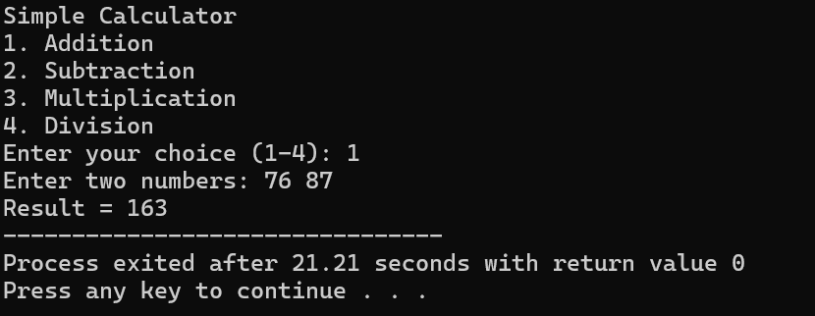

Question 10. Write a program using Switch case to add, subtract, multiply and divide two numbers.
#include <iostream>
using namespace std;

int main() {
float a,b;
int expression;
cout << "Enter the first number :";
cin >> a;
cout << "Enter the second number : ";
cin >> b;
cout <<" Press 1 for add\n press 2 for multiplication\n press 3 for divison :";
cin >> expression;
switch (expression)
{
case 1:
{
float sum = a+b;
cout << " Addition = " << sum;
break;
}
case 2:
{
float mul = a*b;
cout << "Multiplication = " << mul;
break;
}
case 3:
float div = a/b;
cout << "divison = " << div;

}
return 0;
}

Outpu
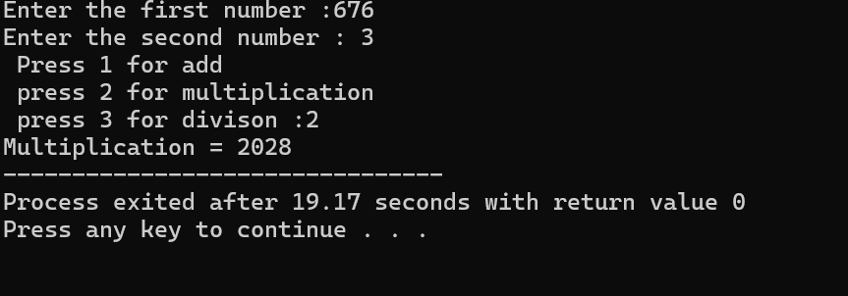
Question 11. Write a Program to Find the Length of a String.
#include <iostream>
#include <cstring>
using namespace std;

int main() {
char str[100];

cout << "Enter a string: ";
cin.getline(str, 100);

int length = strlen(str);

cout << "Length of the string = " << length;

return 0;
}
Output
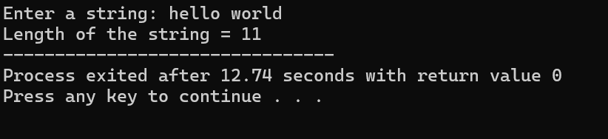

Question 12. Write a program to find the sum of natural numbers using for loop.
#include <iostream>
using namespace std;

int main() {
int n, sum = 0;

cout << "Enter a number: ";
cin >> n;
for(int i = 1; i <= n; i++) {
sum = sum + i;
}

cout << "Sum of natural numbers = " << sum;

return 0;
}
Output
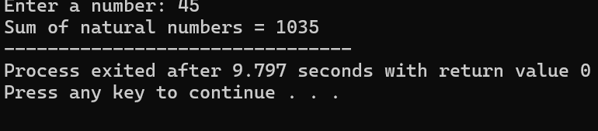
Question 13. Write a Program to Search an Element in an Array (Linear Search).
#include <iostream>
using namespace std;

int main() {
int arr[100], n, key;
bool found = false;

cout << "Enter number of elements: ";
cin >> n;

cout << "Enter elements:\n";
for(int i = 0; i < n; i++) {
cin >> arr[i];
}

cout << "Enter element to search: ";
cin >> key;
for(int i = 0; i < n; i++) {
if(arr[i] == key) {
cout << "Element found at position " << i + 1;
found = true;
break;
}
}

if(!found) {
cout << "Element not found";
}

return 0;
}
Output
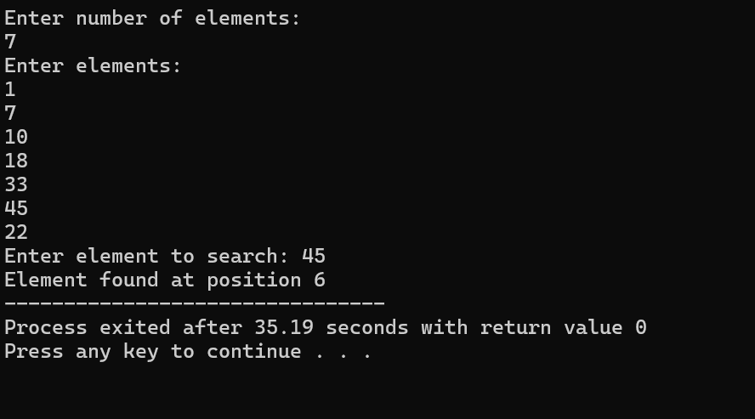

Question 14. Write a Program to Find the Maximum and Minimum in an Array.
#include <iostream>
using namespace std;

int main() {
int arr[100], n;

cout << "Enter number of elements: ";
cin >> n;

cout << "Enter elements:\n";
for(int i = 0; i < n; i++) {
cin >> arr[i];
}
int max = arr[0];
int min = arr[0];
for(int i = 1; i < n; i++) {
if(arr[i] > max) {
max = arr[i];
}
if(arr[i] < min) {
min = arr[i];
}
}

cout << "Maximum element = " << max << endl;
cout << "Minimum element = " << min;

return 0;
}
Output 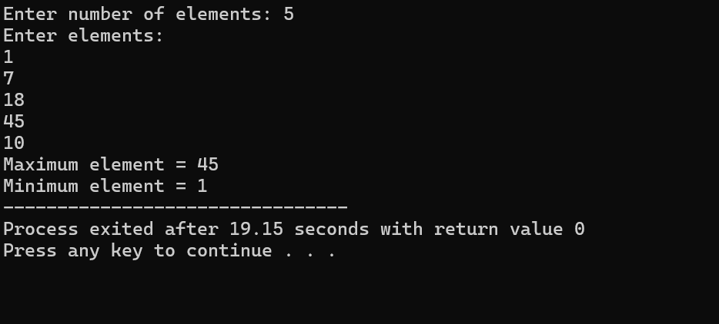

Question 15. Write a program to find the sum of elements in a given array.
#include <iostream>
using namespace std;

int main() {
int arr[100], n, sum = 0;

cout << "Enter number of elements: ";
cin >> n;

cout << "Enter elements:\n";
for(int i = 0; i < n; i++) {
cin >> arr[i];
}
for(int i = 0; i < n; i++) {
sum = sum + arr[i];
}

cout << "Sum of array elements = " << sum;

return 0;
}
Output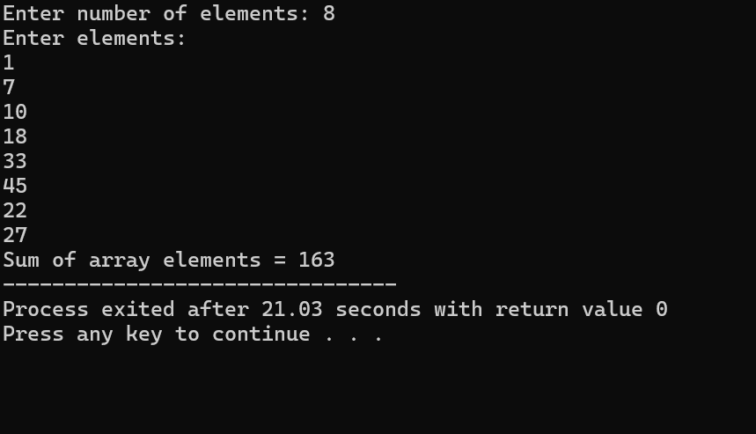
Question 16. Write a program Illustrating Class Declarations, Definition, and Accessing Class Members.
#include <iostream>
using namespace std;
class Student {
private:
int rollNo;
string name;

public:
void setData(int r, string n) {
rollNo = r;
name = n;
}
void display() {
cout << "Roll No: " << rollNo << endl;
cout << "Name: " << name << endl;
}
};

int main() {
Student s;
s.setData(101, "Rohan");
s.display();

return 0;
}
Output
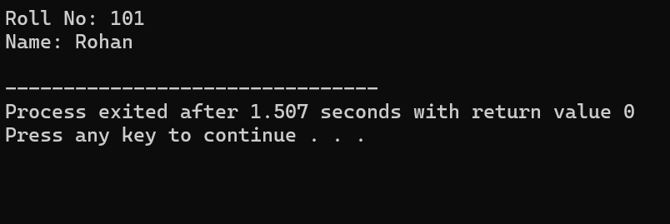
Question 17. Write C++ programs that illustrate how the following forms of inheritance are supported.
- Single inheritance:
#include <iostream>
using namespace std;

class Base {
public:
void show() {
cout << "This is Base class\n";
}
};

class Derived : public Base {
public:
void display() {
cout << "This is Derived class\n";
}
};

int main() {
Derived d;
d.show();
d.display();
return 0;
}

Output
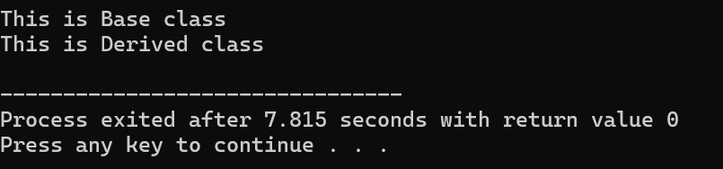

B) Multiple inheritance:
#include <iostream>
using namespace std;

class A {
public:
void showA() {
cout << "Class A\n";
}
};

class B {
public:
void showB() {
cout << "Class B\n";
}
};

class C : public A, public B {
public:
void showC() {
cout << "Class C (Derived)\n";
}
};

int main() {
C obj;
obj.showA();
obj.showB();
obj.showC();
return 0;
}
Output
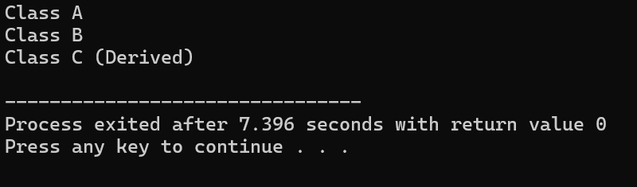

C) Multilevel inheritance:
#include <iostream>
using namespace std;

class A {
public:
void showA() {
cout << "Class A\n";
}
};

class B : public A {
public:
void showB() {
cout << "Class B\n";
}
};

class C : public B {
public:
void showC() {
cout << "Class C\n";
}
};

int main() {
C obj;
obj.showA();
obj.showB();
obj.showC();
return 0;
}
Output
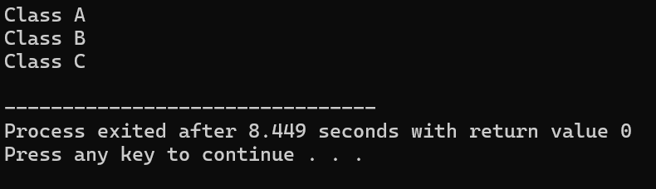

D) Hierarchical Inheritance:
#include <iostream>
using namespace std;

class Base {
public:
void show() {
cout << "This is Base class\n";
}
};

class Derived1 : public Base {
public:
void display1() {
cout << "This is Derived1\n";
}
};

class Derived2 : public Base {
public:
void display2() {
cout << "This is Derived2\n";
}
};

int main() {
Derived1 d1;
Derived2 d2;

d1.show();
d1.display1();

d2.show();
d2.display2();

return 0;
}
Output
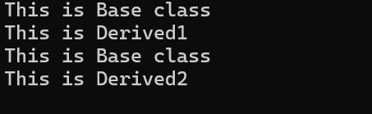

Question 18. Write a Program to Demonstrate
- Operator Overloading.
#include <iostream>
using namespace std;

class A {
public:
int x;
A operator + (A obj) {
A temp;
temp.x = x + obj.x;
return temp;
}
};
int main() {
A a1, a2, a3;
a1.x = 5;
a2.x = 10;
a3 = a1 + a2;
cout << "Sum = " << a3.x;
return 0;
}

Output
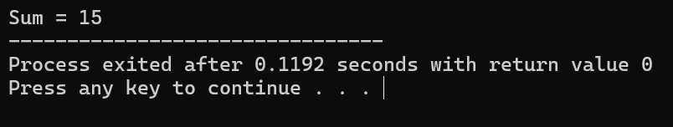
- Simple Function Overloading
#include <iostream>
using namespace std;
int add(int a, int b) {
return a + b;
}

float add(float a, float b) {
return a + b;
}

int main() {
cout << "Sum (int) = " << add(2, 3) << endl;
cout << "Sum (float) = " << add(2.5f, 3.5f);

return 0;
}

Output
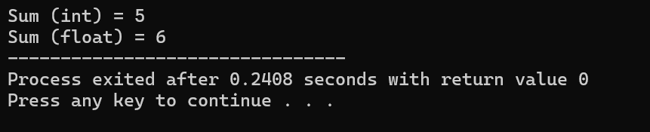
Question 19. Write a program to demonstrate polymorphism by calculating area of rectangle and triangle using a shape class.
#include <iostream>
using namespace std;
class Shape {
public:
virtual void area() {
cout << "Calculating area...\n";
}
};
class Rectangle : public Shape {
int length, width;
public:
Rectangle(int l, int w) {
length = l;
width = w;
}
void area() {
cout << "Area of Rectangle = " << length * width << endl;
}
};
class Triangle : public Shape {
int base, height;
public:
Triangle(int b, int h) {
base = b;
height = h;
}
void area() {
cout << "Area of Triangle = " << 0.5 * base * height << endl;
}
};
int main() {
Shape *s;
Rectangle r(10, 5);
Triangle t(6, 4);
s = &r;
s->area();
s = &t;
s->area();
return 0;
}

Output
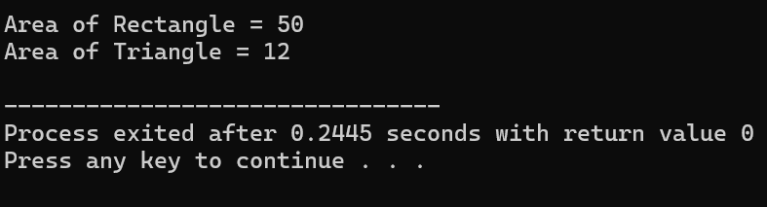
Question 20. Write a Program Containing a Possible Exception. Use a Try Block to Throw it and a Catch Block to Handle it Properly.
#include <iostream>
using namespace std;

int main() {
int a, b;
cout << "Enter two numbers: ";
cin >> a >> b;
try {
if(b == 0) {
throw b;
}
cout << "Result = " << a / b;
}
catch(int x) {
cout << "Error! Division by zero is not allowed.";
}
return 0;
}
Output
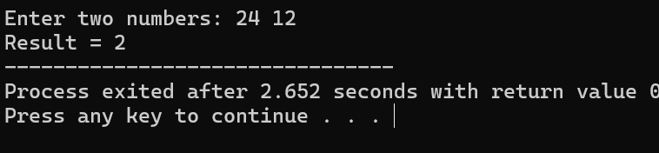
Question 21. Write a Program to Demonstrate the Catching of All Exceptions.
#include <iostream>
using namespace std;
int main() {
int a, b;
cout << "Enter two numbers: ";
cin >> a >> b;
try {
if(b == 0) {
throw "Division by zero error";
}
cout << "Result = " << a / b;
}
catch(...) {
cout << "Exception caught! Something went wrong.";
}
return 0; }
Output
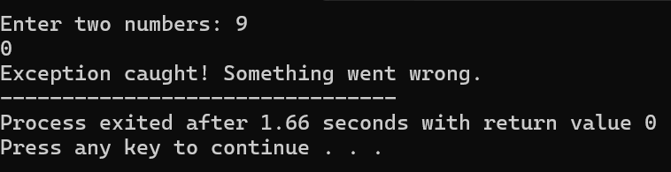
Question 22. Write a program to create a file.
#include <iostream>
#include <fstream>
using namespace std;

int main() {
ofstream file;
file.open("example.txt");
file << "This is a sample file created using C++.";
file.close();
cout << "File created and data written successfully.";
return 0;
}
Output
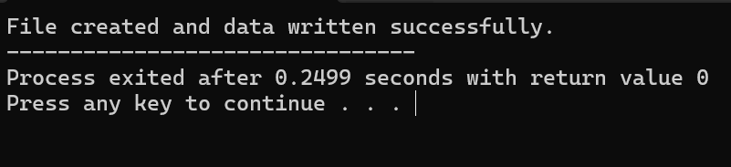
Question 23. Write a program to read a text file.
#include <iostream>
#include <fstream>
using namespace std;
int main() {
ifstream file;
string line;
file.open("example.txt");
if(!file) {
cout << "Error opening file!";
return 1;
}
while(getline(file, line)) {
cout << line << endl;
}
file.close();
return 0;
}
Output
